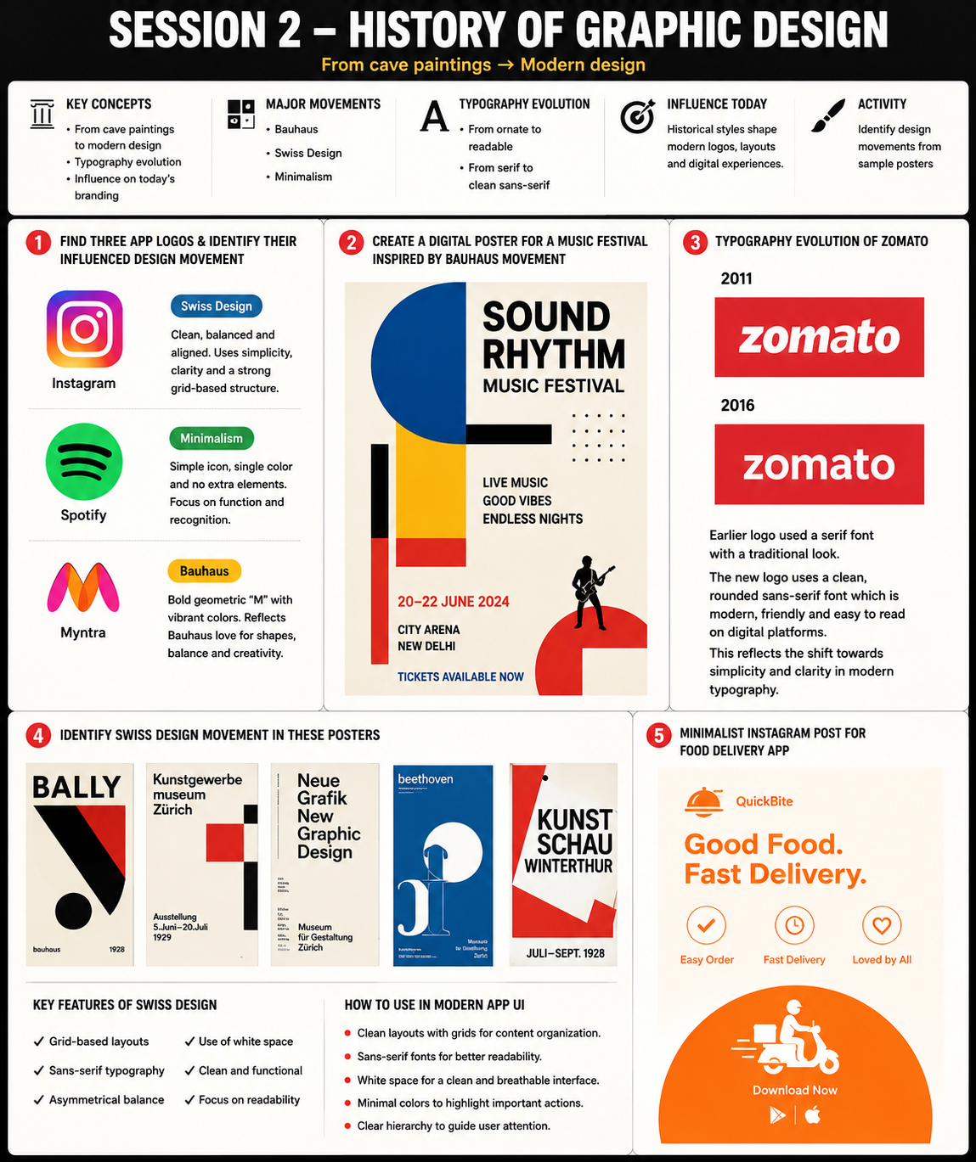 . App Logos & Design Movements
Instagram – Swiss Design
- Instagram's logo uses a simple, balanced, and clean structure.
- The design focuses on clarity and easy recognition.
- This reflects Swiss Design principles of simplicity and visual organization.
Spotify – Minimalism
- Spotify uses a simple circular icon with three curved lines.
- There are no unnecessary details or decorations.
- The logo focuses on functionality and instant recognition, which is a key characteristic of Minimalism.
Myntra – Bauhaus
- Myntra's colorful "M" uses bold geometric forms and bright colors.
- The design combines creativity with simple shapes.
- This reflects Bauhaus principles of combining art, geometry, and functionality.

2. Bauhaus-Inspired Music Festival Poster
Design Features Used:
- Geometric shapes (circle, rectangle, lines)
- Primary colors (red, blue, yellow)
- Bold sans-serif typography
Explanation:
- Bauhaus design emphasizes simplicity and functionality.
- Geometric shapes create structure and visual balance.
- Bold colors attract attention and create strong visual impact.
- Sans-serif fonts improve readability and match the modern Bauhaus style.

3. Typography Evolution of Zomato
Old Logo (2011)
- Used a more traditional and slightly decorative type style.
- The typography appeared heavier and less optimized for digital platforms.
New Logo (2016+)
- Uses a clean sans-serif font.
- Letters are simpler, more modern, and easier to read on screens.
- The redesign follows modern graphic design trends that prioritize clarity and minimalism.
Conclusion:
The evolution reflects the industry's shift toward cleaner, more user-friendly digital branding.

4. Swiss Design Poster Analysis
Key Features of Swiss Design
- Grid-Based Layouts
  - Elements are aligned using structured grids.
  - Creates organization and consistency.
- Sans-Serif Typography
  - Clean and readable fonts.
  - Focuses on communication rather than decoration.
- Use of White Space
  - Empty space improves readability.
  - Prevents visual clutter.
- Asymmetrical Balance
  - Creates visual interest while maintaining harmony.
- Focus on Functionality
  - Every element serves a purpose.
Use in Modern App UI
- Organized layouts improve navigation.
- White space makes interfaces cleaner.
- Sans-serif fonts improve readability on mobile devices.
- Clear hierarchy helps users find information quickly.

5. Minimalist Instagram Post for Food Delivery App
Design Choices:
- Only two colors were used (Orange and White).
- One sans-serif font was used throughout the design.
- Simple icons and geometric shapes were included.
Why It Works:
- Orange creates energy, warmth, and appetite.
- White provides contrast and cleanliness.
- Minimal elements keep the message clear and focused.
- Users can quickly understand the offer without distractions.

Conclusion

